Configuring Cassandra
- Cassandra Cluster Manager
- Creating a Cluster
- Seed Nodes
- Partitioners
- Murmur3 Partitioner
- Random Partitioner
- Order-Preserving Partitioner
- ByteOrderedPartitioner
- Snitches
- Simple Snitch
- Property File Snitch
- Gossiping Property File Snitch
- Rack Inferring Snitch
- Cloud Snitches
- Dynamic Snitch
- Node Configuration
- Tokens and Virtual Nodes
- Network Interfaces [07/28]
- Data Storage
- Startup and JVM Settings
- Adding Nodes to a Cluster
- Dynamic Ring Participation [07/29
- Replication Strategies
- SimpleStrategy
- NetworkTopologyStrategy
- Changing the Replication Factor [07/30]

Cassandra Clients
- Hector, Astyanax, and Other Legacy Clients
- DataStax Java Driver
- Development Environment Configuration
- Clusters and Contact Points
- Sessions and Connection Pooling [07/31
- Statements [08/01]
- Policies
- Metadata
- Debugging and Monitoring [08/02]

Reading and Writing Data
- Writing
- Write Consistency Levels
- The Cassandra Write Path
- Writing Files to Disk [08/03]
- Lightweight Transactions
- Batches [08/04]
- Reading
- Read Consistency Levels
- The Cassandra Read Path
- Read Repair
- Range Queries, Ordering and Filtering [08/05]
- Functions and Aggregates
- Paging [08/06]
- Speculative Retry
- Deleting [08/07]

Monitoring
- Logging
- Tailing
- Examining Log Files
- Monitoring Cassandra with JMX [08/11]
- Connecting to Cassandra via JConsole
- Overview of MBeans [08/12]
- Cassandra’s MBeans
- Database MBeans
- Networking MBeans [08/13]
- Metrics MBeans
- Threading MBeans
- Service MBeans
- Security MBeans [08/14]
- Monitoring with nodetool
- Getting Cluster Information
- Getting Statistics [08/15]
Maintenance
- Health Check
- Basic Maintenance
  - Flush
  - Cleanup
  - Repair [08/16]
  - Rebuilding Indexes
  - Moving Tokens
- Adding Nodes
  - Adding Nodes to an Existing Data Center
  - Adding a Data Center to a Cluster
- Handling Node Failure
  - Repairing Nodes
  - Replacing Nodes [08/17]
  - Removing Nodes
- Upgrading Cassandra
- Backup and Recovery
  - Taking a Snapshot [08/18]
  - Clearing a Snapshot
  - Enabling Incremental Backup
  - Restoring from Snapshot
- SSTable Utilities
- Maintenance Tools
  - DataStax OpsCenter
  - Netflix Priam [08/19]
Performance Tuning
- Managing Performance
  - Setting Performance Goals
  - Monitoring Performance
  - Analyzing Performance Issues [08/20]
  - Tracing
  - Tuning Methodology
- Caching
  - Key Cache
  - Row Cache
  - Counter Cache
  - Saved Cache Settings [08/21]
- Memtables
- Commit Logs
- SSTables
- Hinted Handoff [08/22]
- Compaction
- Concurrency and Threading
- Networking and Timeouts [08/23]
- JVM Settings
  - Memory
  - Garbage Collection
- Using Cassandra-stress [08/27]
Security
- Authentication and Authorization
  - Password Authenticator [08/28]
  - Using CassandraAuthorizer
  - Role-Based Access Control
- Encryption
  - SSL, TLS, and Certificates
  - Node-to-Node Encryption [08/29]
  - Client-to-Node Encryption
- JMX Security
  - Securing JMX Access
  - Security MBeans [08/30]
Deploying and Integrating
- Planning a Cluster Deployment
  - Sizing Your Cluster
  - Selecting Instances
  - Storage
  - Network [09/01]
- Cloud Deployment
  - Amazon Web Services
  - Microsoft Azure
  - Google Cloud Platform [09/02]
- Integrations
  - Apache Lucene, SOLR, and Elastic search
  - Apache Hadoop [09/03]
  - Apache Spark [09/04]

CHAPTER 7

Configuring Cassandra

In this chapter, we’ll build our first cluster and look at the available options for con‐ figuring Cassandra. Out of the box, Cassandra works with no configuration at all; you can simply download and decompress, and then execute the program to start the server with its default configuration.

Cassandra Cluster Manager

In order to get practice in building and configuring a cluster, we’ll take advantage of a tool called the Cassandra Cluster Manager or ccm. This tool is a set of Python scripts that allow you to run a multi-node cluster on a single machine. This allows you to quickly configure a cluster without having to provision additional hardware.

How to get the tool from GitHub and Use it:

The tool is available on GitHub. A quick way to get started is to clone the repository using Git. We’ll open a terminal window and navigate to a directory where we want to create our clone and run the following command:

$ git clone https://github.com/pcmanus/ccm.git

Then we can to run the installation script with administrative-level privileges:

$ sudo ./setup.py install

131

Once you’ve installed ccm, it should be on the system path. To get a list of supported commands, you can type ccm or ccm –help. If you need more information on the options for a specific cluster command, type ccm <command> -h.

Creating a Cluster

In this section, we’ll learn about the configuration required to get multiple Cassandra instances to talk to each other in a ring. The key file for configuring each node in a cluster is the cassandra.yaml file, which you can find in the conf directory under your Cassandra installation.

The key values in configuring a cluster are the
- Cluster name,
- The partitioner,
- The snitch
- The seed nodes.
Note: The cluster name, partitioner, and snitch must be the same in all of the nodes participating in the cluster.

The name of the default cluster in the cassandra.yaml file is Test Cluster.

How to change the cluster Name?

You can change the name of the cluster by updating the cluster_name property—just make sure that you have done this on all nodes that you want to participate in this cluster.

Note: If you have written data to an existing Cassandra cluster and then change the cluster name, Cassandra will warn you with a cluster name mismatch error as it tries to read the data files on startup, and then it will shut down.

132 | Chapter 7: Configuring Cassandra

Let’s try creating a cluster using ccm tool:

$ ccm create -v 3.0.0 -n 3 my_cluster --vnodes

Downloading http://archive.apache.org/dist/cassandra/3.0.0/ apache-cassandra-3.0.0-src.tar.gz to /var/folders/63/6h7dm1k51bd6phvm7fbngskc0000gt/T/
ccm-z2kHp0.tar.gz (22.934MB)

24048379 [100.00%]

Extracting /var/folders/63/6h7dm1k51bd6phvm7fbngskc0000gt/T/ ccm-z2kHp0.tar.gz as version 3.0.0 ...
Compiling Cassandra 3.0.0 ...

Current cluster is now: my_cluster

- This command creates a cluster based on the version of Cassandra we selected—in this case, 3.0.0.
- The cluster is named my_cluster and has three nodes.
- We specify that we want to use virtual nodes, because ccm defaults to creating single token nodes. ccm designates our cluster as the current cluster that will be used for subsequent commands.

Note: You’ll notice that ccm downloads the source for the version requested to run and compiles it. This is because ccm needs to make some minor modifications to the Cassandra source in order to support running multiple nodes on a single machine.

How to validate whether the cluster has created or not?

[Run bin/Cassandra script]

Once we’ve created the cluster, we can see it is the only cluster in our list of clusters (and marked as the default), and we can learn about its status:

$ ccm list

*my_cluster

$ ccm status

Cluster: 'my_cluster'

---------------------

node1: DOWN (Not initialized)

node3: DOWN (Not initialized)

node2: DOWN (Not initialized)

At this point, none of the nodes have been initialized. Let’s start our cluster and then check status again:

$ ccm start

$ ccm status

Cluster: 'my_cluster'

---------------------

node1: UP

node3: UP

node2: UP
How to validate the status of each individual node?
[nodetool status ]

To dig deeper on the status of an individual node, we’ll enter the following command:

$ ccm node1 status

Datacenter: datacenter1
=======================
Status=Up/Down
|/ State=Normal/Leaving/Joining/Moving
-- | Address | Load |  | Tokens | Owns | Host_ID | Rack
UN | 127.0.0.1 | 193.2 | KB | 256 | ? | e5a6b739-... rack1
UN | 127.0.0.2 | 68.45 | KB | 256 | ? | 48843ab4-... rack1
UN | 127.0.0.3 | 68.5 | KB | 256 | ? | dd728f0b-... rack1

This is equivalent to running the command nodetool status on the individual node. The output shows that
- All of the nodes are up and reporting normal status (UN).
- Each of the nodes has 256 tokens, and owns no data, as we haven’t inserted any data yet.
- We’ve shortened the host ID somewhat for brevity.

We can run the nodetool ring command in order to get a list of the tokens owned by each node. To do this in ccm, we enter the command:

$ ccm node1 ring

Datacenter: datacenter1
==========
Address | Rack | Status | State | ... | Token
 |  |  |  |  | 9205346612887953633
127.0.0.1 | rack1 | Up | Normal | ... | -9211073930147845649
127.0.0.3 | rack1 | Up | Normal | ... | -9114803904447515108
127.0.0.3 | rack1 | Up | Normal | ... | -9091620194155459357
127.0.0.1 | rack1 | Up | Normal | ... | -9068215598443754923
127.0.0.2 | rack1 | Up | Normal | ... | -9063205907969085747

The command requires us to specify a node. The tokens are allocated randomly across our three nodes.

134 | Chapter 7: Configuring Cassandra

How to compare the configuration between two nodes?

Between nodes, try using the diff command to compare the contents of the directories. For example:

$ cd ~/.ccm/my_cluster

$ diff node1/conf/ node2/conf/

The above is basically a simple UNIX command to output the differences in the configuration files, including the directories used for storage of data, commit logs and output logs etc.

Seed Nodes

The seed node has no purpose other than bootstrapping the gossip process for new nodes joining the cluster. So, without at least one live seed node, no new nodes can join the cluster because they have no idea how to contact non-seed nodes to get the cluster status.

For example, if node A acts as a seed for node B, when node B comes online, it will use node A as a reference point from which to get data. This process is known as bootstrapping.

The cassandra.yaml file seed entry location:

- seeds: 127.0.0.1, 127.0.0.2, 127.0.0.3

Seed Nodes | 135

Partitioners

The purpose of the partitioner is to allow you to specify how partition keys should be sorted, which has a significant impact on how data will be distributed across your nodes.

You set the partitioner by updating the value of the partitioner property in the cassan‐ dra.yaml file.

Changing the Partitioner


You can’t change the partitioner once you’ve inserted data into a cluster, so take care before deviating from the default!

There are a few different partitioners you can use.

- Murmur3 Partitioner

The default partitioner is org.apache.cassandra.dht.Murmur3Partitioner.
The Murmur3Partitioner uses the murmur hash algorithm to generate tokens.
This has the advantage of spreading your keys evenly across your cluster.
.

- Random Partitioner

The random partitioner is implemented by org.apache.cassandra.dht.Ran domPartitioner and was Cassandra’s default in Cassandra 1.1 and earlier. But RandomPartitioner is slower than Murmur3Partitioner.

- Order-Preserving Partitioner

- ByteOrderedPartitioner

- Summary of Partitioner:

- The purpose of the partitioner is to allow you to specify how partition keys should be sorted.
- Earlier version of Cassandra used Random Partitioner whereas the current version uses Murmur3 Partitioner which internally use murmur hash algorithm.

Question: What is the difference between Gossip and Snitch?

Gossip is a protocol and Snitch is a component which utilizes it.

Therefore, Gossip is used to identify the state of machines (are they in the cluster, up/down/joining/leaving).

The snitches help map ownership to an actual machine, and route queries (given these 10 nodes in the cluster, which of the 10 own the data for a given key).

Snitches

The job of a snitch is simply to determine relative host proximity. by gathering information about the network topology so that Cassandra can efficiently route requests.

You configure the endpoint snitch implementation to use by updating the endpoint snitch property in the cassandra.yaml file.

- Simple Snitch [not rack-aware snitch]

By default, Cassandra uses org.apache.cassandra.locator.SimpleSnitch. This snitch is not rack-aware, which makes it unsuitable for multi-data center deployments.

Note: If you choose to use this snitch, you should also use the SimpleStrategy replication strategy for your keyspaces.

- Property File Snitch [rack-aware snitch]

The org.apache.cassandra.locator.PropertyFileSnitch is what is known as a rack-aware snitch, meaning that it uses information you provide about the topology of your cluster in a standard Java key/value properties file called cassandra-topology.properties. The default configuration of cassandra-topology.properties looks like this:

- Cassandra Node IP=Data Center:Rack 192.168.1.100=DC1:RAC1
192.168.2.200=DC2:RAC2

10.0.0.10=DC1:RAC1

10.0.0.11=DC1:RAC1

10.0.0.12=DC1:RAC2

138 | Chapter 7: Configuring Cassandra

10.20.114.10=DC2:RAC1

10.20.114.11=DC2:RAC1

10.21.119.13=DC3:RAC1

10.21.119.10=DC3:RAC1

10.0.0.13=DC1:RAC2

10.21.119.14=DC3:RAC2

10.20.114.15=DC2:RAC2

- default for unknown nodes default=DC1:r1

Here we see that there are three data centers (DC1, DC2, and DC3), each with two racks (RAC1 and RAC2). Any nodes that aren’t identified here will be assumed to be in the default data center and rack (DC1, r1).

If you choose to use this snitch or one of the other rack-aware snitches, these are the same rack and data names that you will use in configuring the NetworkTopology Strategy settings per data center for your keyspace replication strategies.

- Gossiping Property File Snitch [rack-aware snitch]

- Rack Inferring Snitch

Snitches | 139

- Cloud Snitches

This type of snitches designed for use in cloud deployments:

- Dynamic Snitch

Cassandra wraps your selected snitch with a org.apache.cassandra.locator.DynamicEndpointSnitch in order to select the highest performing nodes for queries.

Note: The dynamic_snitch_badness_threshold property defines a threshold for changing the preferred node. The default value of 0.1 means that the preferred node must perform 10% worse than the fastest node in order to be lose its status.

- Summary of Snitches:

- The job of a snitch is simply to determine relative host proximity.
- There are mainly two type of snitches.
  - Rack-aware
  - Rack-unaware
- For rack-unaware snitch, we need to use SimpleStrategy replication strategy. But for rack-aware snitch, we can use NetworkTopology replication strategy.

What is Node Configuration? [Not Important]

Besides the cluster-related settings as we discussed earlier, there are many other properties that can be set in the cassandra.yaml file in order to configure nodes in the cluster.

- Tokens and Virtual Nodes

By default, Cassandra is configured to use virtual nodes (vnodes). The number of tokens that a given node will service is set by the num_tokens property. Generally this should be left at the default value (currently 256).

- Network Interfaces

There are several properties in the cassandra.yaml file that relate to the networking of the node in terms of ports and protocols used for communications with clients and other nodes:

$ cd ~/.ccm

$ find . -name cassandra.yaml -exec grep -H 'listen_address' {} \;

./node1/conf/cassandra.yaml:listen_address: 127.0.0.1

./node2/conf/cassandra.yaml:listen_address: 127.0.0.2

./node3/conf/cassandra.yaml:listen_address: 127.0.0.3

If you’d prefer to bind via an interface name, you can use the listen_interface property instead of listen_address. For example, listen_interface=eth0. You may not set both of these properties.

Data Storage

Cassandra allows you to configure how and where its various data files are stored on disk, including data files, commit logs, and saved caches. The default is the data directory under your Cassandra installation ($CASSANDRA_HOME/data or %CAS‐ SANDRA_HOME%/data).

- Commit logs are stored in the location specified by the commitlog_directory property.

- Data files are stored in the location specified by the data_file_directories property.

Startup and JVM Settings

- Optimize JVM configuration file location conf/cassandra.env.sh. This file contains settings to configure the JVM version

- Cassandra’s logging configuration is found in the conf/logback.xml file. This file includes settings such as the log level, message formatting, and log file settings including locations, maximum sizes, and rotation.

Adding Nodes to a Cluster

Now that you have an understanding of what goes into configuring each node of a Cassandra cluster, you’re ready to learn how to add nodes. As we’ve already discussed, to add a new node manually, we need to configure the cassandra.yaml file for the new node to set the seed nodes, partitioner, snitch, and network ports. If you’ve elected to create single token nodes, you’ll also need to calculate the token range for the new node and make adjustments to the ranges of other nodes.

Because we’re using ccm, the process of adding a new node is quite simple. We run the following command:

$ ccm add node4 -i 127.0.0.4 -j 7400

144 | Chapter 7: Configuring Cassandra

This creates a new node, node4, with another loopback address and JMX port set to 7400. To see additional options for this command you can type ccm add –h. Now that we’ve added a node, let’s check the status of our cluster:

$ ccm status

Cluster: 'my_cluster'

---------------------

node1: UP

node3: UP

node2: UP

node4: DOWN (Not initialized)

The new node has been added but has not been started yet. If you run the nodetool ring command again, you’ll see that no changes have been made to the tokens. Now we’re ready to start the new node by typing ccm node4 start (after double-checking that the additional loopback address is enabled). If you run the nodetool ring com‐ mand once more, you’ll see output similar to the following:

Datacenter: datacenter1
==========
Address | Rack | Status | State | ... | Token
 |  |  |  |  | 9218701579919475223
127.0.0.1 | rack1 | Up | Normal | ... | -9211073930147845649
127.0.0.4 | rack1 | Up | Normal | ... | -9190530381068170163
...

If you compare this with the previous output, you’ll notice a couple of things. First, the tokens have been reallocated across all of the nodes, including our new node. Sec‐ ond, the token values have changed representing smaller ranges. In order to give our new node its 256 tokens (num_tokens), we now have 1,024 total tokens in the cluster.

We can observe what it looks like to other nodes when node4 starts up by examining the log file. On a standalone node, you might look at the system.log file in /var/log/ cassandra (or $CASSANDRA_HOME/logs), depending on your configuration. Because we’re using ccm, there is a handy command that we can use to examine the log files from any node. We’ll look at the node1 log using the command: ccm node1 showlog. This brings up a view similar to the standard unix more command that allows us to page through or search the log file contents. Searching for gossip-related statements in the log file near the end, we find the following:

INFO [GossipStage:1] 2015-08-24 20:02:24,377 Gossiper.java:1005 – Node /127.0.0.4 is now part of the cluster

INFO [HANDSHAKE-/127.0.0.4] 2015-08-24 20:02:24,380 OutboundTcpConnection.java:494 - Handshaking version with /127.0.0.4

INFO [SharedPool-Worker-1] 2015-08-24 20:02:24,383 Gossiper.java:970 - InetAddress /127.0.0.4 is now UP

Adding Nodes to a Cluster | 145

These statements show node1 successfully gossiping with node4 and that node4 is considered up and part of the cluster. At this point, the bootstrapping process begins to allocate tokens to node4 and stream any data associated with those tokens to node4.

Dynamic Ring Participation

Nodes in a Cassandra cluster can be brought down and brought back up without dis‐ ruption to the rest of the cluster (assuming a reasonable replication factor and consis‐ tency level). Say that we have started a two-node cluster as described earlier in “Creating a Cluster” on page 132. We can cause an error to occur that will take down one of the nodes, and then make sure that the rest of the cluster is still OK.

We’ll simulate this by taking one of our nodes down using the ccm node4 stop com‐ mand. We can run the ccm status to verify the node is down, and then check a log file as we did earlier via the command ccm node1 showlog. Examining the log file we’ll see some lines like the following:

INFO [GossipStage:1] 2015-08-27 19:31:24,196 Gossiper.java:984 - InetAddress /127.0.0.4 is now DOWN

INFO [HANDSHAKE-/127.0.0.4] 2015-08-27 19:31:24,745 OutboundTcpConnection.java:494 - Handshaking version with /127.0.0.4

Now we bring node4 back up and recheck the logs at node1. Sure enough, Cassandra has automatically detected that the other participant has returned to the cluster and is again open for business:

INFO [HANDSHAKE-/127.0.0.4] 2015-08-27 19:32:56,733 OutboundTcpConnection

.java:494 - Handshaking version with /127.0.0.4

INFO [GossipStage:1] 2015-08-27 19:32:57,574 Gossiper.java:1003 - Node /127.0.0.4 has restarted, now UP

INFO [SharedPool-Worker-1] 2015-08-27 19:32:57,652 Gossiper.java:970 - InetAddress /127.0.0.4 is now UP

INFO [GossipStage:1] 2015-08-27 19:32:58,115 StorageService.java:1886 - Node /127.0.0.4 state jump to normal

The state jump to normal for node4 indicates that it’s part of the cluster again. As a final check, we run the status command again and see that the node is back up:

$ ccm status

Cluster: 'my_cluster'

---------------------

node1: UP

node2: UP

node3: UP

node4: UP

146 | Chapter 7: Configuring Cassandra

Replication Strategies

While we’ve spent a good amount of time learning about the various configuration options for our cluster and nodes, Cassandra also provides flexible configuration of keyspaces and tables. These values are accessed using cqlsh, or they may also be accessed via the client driver in use, which we’ll learn about in Chapter 8.

cqlsh> DESCRIBE KEYSPACE my_keyspace ;

CREATE KEYSPACE my_keyspace WITH replication = {'class': 'SimpleStrategy',
'replication_factor': '1'} AND durable_writes = true;

What Are Durable Writes?


The durable_writes property allows you to bypass writing to the commit log for the keyspace. This value defaults to true, meaning that the commit log will be updated on modifications. Setting the value to false increases the speed of writes, but also has the risk of losing data if the node goes down before the data is flushed from memtables into SSTables.

Choosing the right replication strategy is important because the strategy determines which nodes are responsible for which key ranges. The implication is that you’re also determining which nodes should receive which write operations, which can have a big impact on efficiency in different scenarios. If you set up your cluster such that all writes are going to two data centers—one in Australia and one in Reston, Virginia— you will see a matching performance degradation. The selection of pluggable strate‐ gies allows you greater flexibility, so that you can tune Cassandra according to your network topology and needs.

The first replica will always be the node that claims the range in which the token falls, but the remainder of the replicas are placed according to the replication strategy you use.

As we learned in Chapter 6, Cassandra provides two replication strategies, the

SimpleStrategy and the NetworkTopologyStrategy.

SimpleStrategy

The SimpleStrategy places replicas in a single data center, in a manner that is not aware of their placement on a data center rack. This means that the implementation is theoretically fast, but not if the next node that has the given key is in a different rack than others. This is shown in Figure 7-1.

Replication Strategies | 147

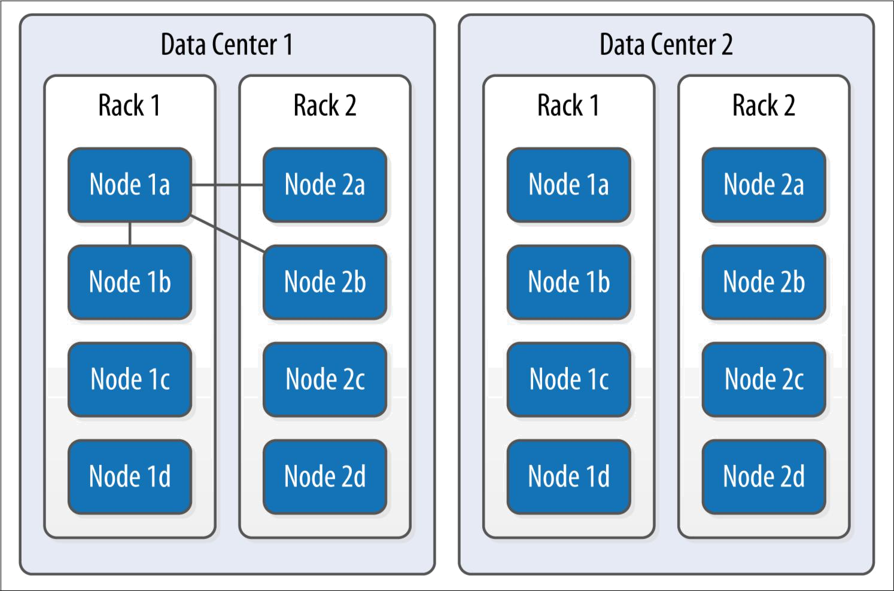

Figure 7-1. The SimpleStrategy places replicas in a single data center, without respect to topology

What’s happening here is that the next N nodes on the ring are chosen to hold repli‐ cas, and the strategy has no notion of data centers. A second data center is shown in the diagram to highlight the fact that the strategy is unaware of it.

NetworkTopologyStrategy

Now let’s say you want to spread replicas across multiple centers in case one of the data centers suffers some kind of catastrophic failure or network outage. The Network TopologyStrategy allows you to request that some replicas be placed in DC1, and some in DC2. Within each data center, the NetworkTopologyStrategy distributes replicas on distinct racks, as nodes in the same rack (or similar physical grouping) often fail at the same time due to power, cooling, or network issues.

The NetworkTopologyStrategy distributes the replicas as follows: the first replica is replaced according to the selected partitioner. Subsequent replicas are placed by tra‐ versing the nodes in the ring, skipping nodes in the same rack until a node in another rack is found. The process repeats for additional replicas, placing them on separate racks. Once a replica has been placed in each rack, the skipped nodes are used to place replicas until the replication factor has been met.

148 | Chapter 7: Configuring Cassandra

The NetworkTopologyStrategy allows you to specify a replication factor for each data center. Thus, the total number of replicas that will be stored is equal to the sum of the replication factors for each data center. The results of the NetworkTopology Strategy are depicted in Figure 7-2.
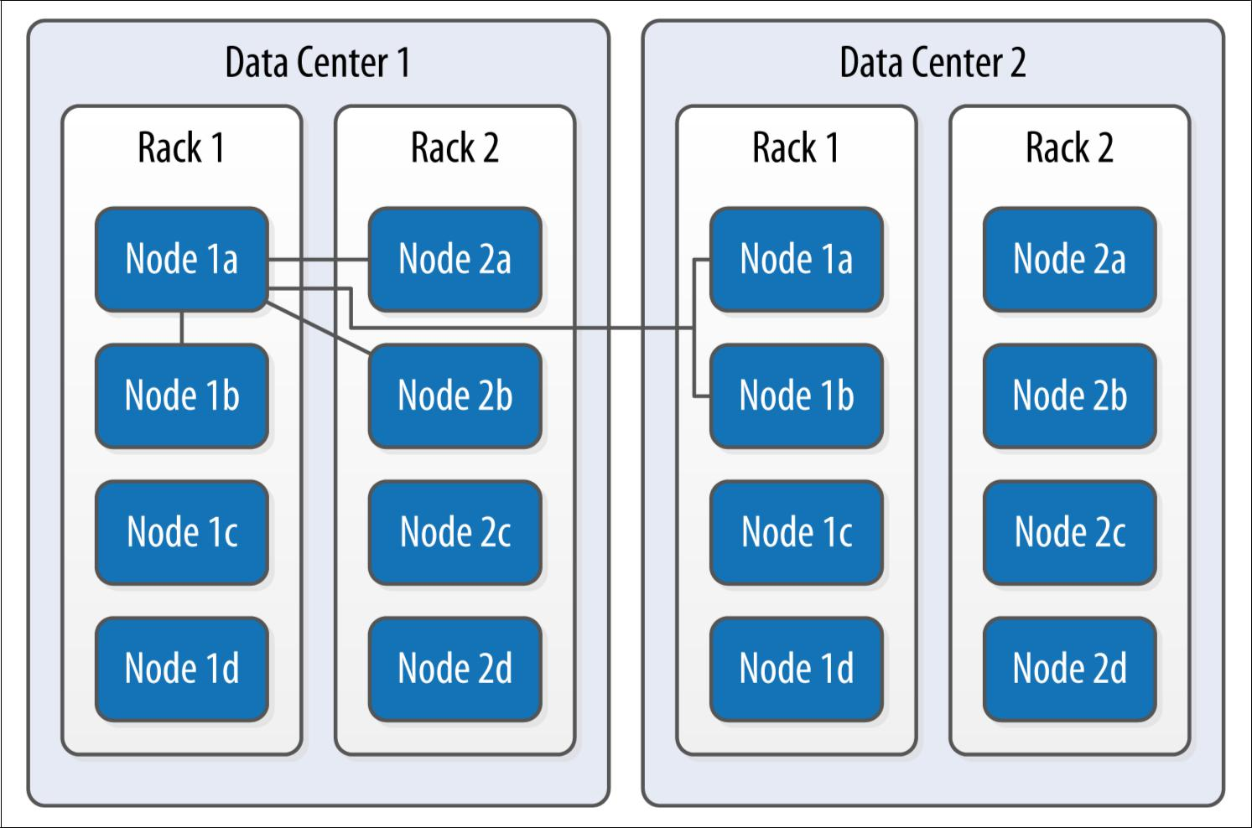

Figure 7-2. The NetworkTopologyStrategy places replicas in multiple data centers accord‐ ing to the specified replication factor per data center

Additional Replication Strategies

Careful observers will note that there are actually two additional replication strategies that ship with Cassandra: the OldNet
workTopologyStrategy and the LocalStrategy.

The OldNetworkTopologyStrategy is similar to the NetworkTopol ogyStrategy in that it places replicas in multiple data centers, but its algorithm is less sophisticated. It places the second replica in a different data center from the first, the third replica in a different rack in the first data center, and any remaining replicas by travers‐ ing subsequent nodes on the ring.

The LocalStrategy is reserved for Cassandra’s own internal use. As the name implies, the LocalStrategy keeps data only on the local node and does not replicate this data to other nodes. Cassan‐ dra uses this strategy for system keyspaces that store metadata about the local node and other nodes in the cluster.

Replication Strategies | 149

Changing the Replication Factor

You can change the replication factor for an existing keyspace via cqlsh or another client. For the change to fully take effect, you’ll need to run a nodetool command on each of the affected nodes. If you increase the replication factor for a cluster (or data center), run the nodetool repair command on each of the nodes in the cluster (or data center) to make sure Cassandra generates the additional replicas. For as long as the repair takes, it is possible that some clients will receive a notice that data does not exist if they connect to a replica that doesn’t have the data yet.

If you decrease the replication factor for a cluster (or data center), run the nodetool clean command on each of the nodes in the cluster (or data center) so that Cassan‐ dra frees up the space associated with unneeded replicas. We’ll learn more about repair, clean, and other nodetool commands in Chapter 11.

As a general guideline, you can anticipate that your write throughput capacity will be the number of nodes divided by your replication factor. So in a 10-node cluster that typically does 10,000 writes per second with a replication factor of 1, if you increase the replication factor to 2, you can expect to do around 5,000 writes per second.

Summary

In this chapter, we looked at how to create Cassandra clusters and add additional nodes to a cluster. We learned how to configure Cassandra nodes via the cassan‐ dra.yaml file, including setting the seed nodes, the partitioner, the snitch, and other settings. We also learned how to configure replication for a keyspace and how to select an appropriate replication strategy.

150 | Chapter 7: Configuring Cassandra

